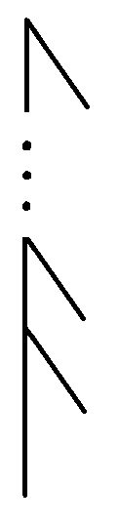There have been some neurological surgeries, where the connection between the two hemispheres of a human brain were severed. The result is that the patient behaves in all observable respects, as if he has two separate minds in the same body. This raises some nerdy moral conundrums, since ethical theories tend to use some concepts or quantities that become ill-defined in such situations. Take for instance, the number of persons existing throughout time. If a human starts out as one person, but ends up as two, how many people will then exist throughout time? The answer seems ill-defined. The same goes for such things as the concept of a person, of inequality in wellbeing across persons, of the self-interest of a person etc.

I have devised a mathematical theory that can be applied to concepts that are well-defined for ordinary minds and be used to provide them with a natural generalization, that will render them well-defined for splitting and merging minds. I have implemented this theory in the Python code called merging_minds for the special case that is shown on the figure to the right. The lines on this figure represents streams of consciousness that are repeatedly merging.

The absence of comments in this code is due to the fact that I never expected to show it to others.